# Copyright © 2018 Muhammad Usman Sadiq

All rights reserved. This code, data and derivatives are being shared for academic purposes only. Production of these items for publication or commercial purposes is strictly prohibited.

Redistribution, copying and renaming of these items are also strictly prohibited.

Users are free to modify, use and build derivatives of this code. Should such modifications lead to a publication or commercial application, explicit permission is required from the authors (Fahad Zafar, Sara Tanzeel and Muhammad Usman Sadiq) after appropriate credits and authorship rights are applied.

# Readme

## Following Packages are required:

* **Bazel** ([instructions](https://docs.bazel.build/versions/master/install.html))
* **Tensorflow** ([instructions](https://www.tensorflow.org/install/))
  + 1 Tensorflow version is required for im2txt (Less than 1) – ***Tested on 0.12.1***
  + 1 Tensorflow version is required for Action Recognition (Greater than 1) – ***Tested on 1.4.0***
  + As more than 1 Tensorflow versions cannot be installed on a single Python Version. Thus, one TF version will be on Python 2 and other one on Python 3.
  + ***Tested with Python 2 and Tensorflow 0.12.1, Python 3 and Tensorflow 1.4.0***
* **NumPy** ([instructions](https://www.scipy.org/install.html))
* **Natural Language Toolkit (NLTK)**
  + First install NLTK ([instructions](http://www.nltk.org/install.html))
  + Then install the NLTK Data Package “punkt” ([instructions](http://www.nltk.org/data.html))

## After installation of packages:

1. Go to this **im2txt** directory from your terminal – cd <path>/im2txt

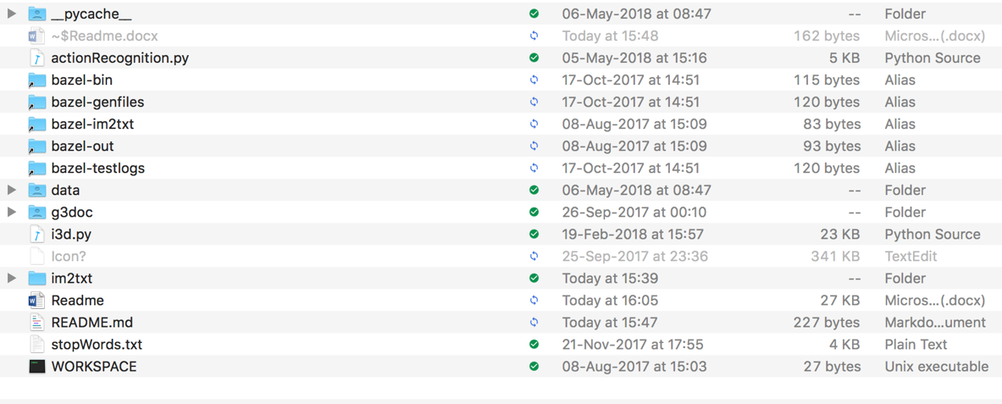

1. Type:

bazel build -c opt im2txt/run_inference

Output will be like this:

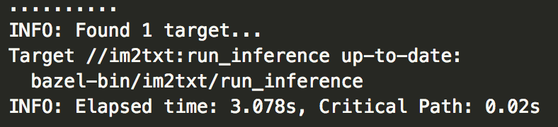

**This “bazel build –c opt im2txt/run_inference” has to be executed only for the first time.**

1. Do the following then:
   * Go to the “run_inference.py” file and change lines 141-146 according to your system.

* Then, go to the im2txt/gui folder, and open up “gui.py” file.
* On line 66, change the directories according to your own placement of im2txt folder
* On line 67, change the directories of Checkpoint File and Vocabulary File.

1. Considering you’re in the **gui** directory, do the following:

python gui.py

1. Select the video you want to add captions to, and click “Start”.